freETarget
Application Note: Large Scale WiFI

INTRODUCTION
FreeETarget was originally build with the target acting as an Access Point, i.e. the target has an SSID (usually FET-TARGET) and the PC connects to the access point. This was done since it simplified the WiFi operation for people who are uncomfortable with WiFi settings. Selecting FET-TARGET and using the default settings in the PC Client are enough to connect the target to the PC.
This works fine for locations with one or two targets, but with more than that it becomes harder to manage the hardware. To address this issue, FreeETarget can be used in Station Mode to allow any number of targets to be used on a range. This document describes the steps to do this:
- Setup the range
- Setup the router
- Connect the targets
- Access the targets
When this is done, the target behaves like any other device you have in your home or office. You can access it anywhere there is a WiFi connection at your location.
This document details two methods of setting up the shooting range:
- Preferred – Maximum network use
- Simple – Low cost installation
The preferred method uses a dedicated router to assign IP addresses and manage the room. It is preferred since it uses a router to manage the room, and with a bit of management you can connect the target to the outside world for maintenance or shared targets.
The simple method uses one of the targets as an access point to dispense IP addresses, and eliminates the expense of a dedicated router. The simple method is limited to small target ranges where the distance between targets and PCs is no more than 30 meters.

SETUP THE RANGE (PREFERRED)
The range is setup as shown in Figure 1. The targets are installed as usual and located nearby is the WiFi router. The router should be no more than forty (30) meters from the targets. The Shooter’s PC should be located such that they get a strong signal from the router.
WiFi routers come with the ability to directly connect the PC to the router using an Ethernet cable. Leave this in place since it allows remote diagnostics via TeamViewer and the service PC.
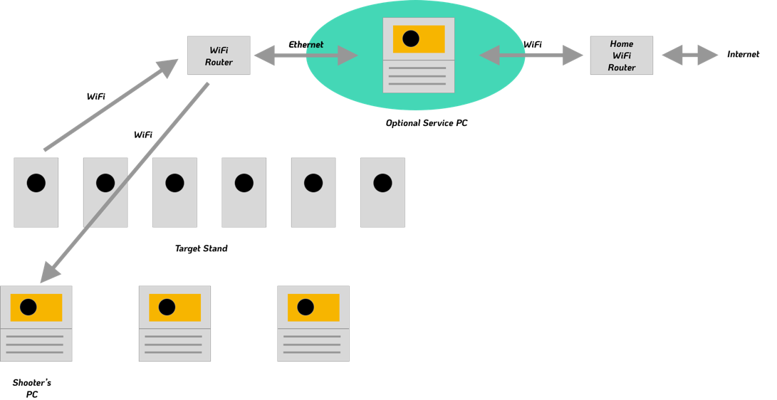
Figure 1: Preferred Range Setup
Router Setup
The router should be setup for the convenience of the shooter and their PC. The following settings are suggested.
Setting | Value | Description
SSID | TargetRange | Easy to recognize
Password | None (open wifi) | No secure data, easy to access for members
IP Address | 192.168.109.x | Unique IP address that will not likely conflict with other networks

Target Setup
The target should be setup with the following values
Setting | Description
{“WIFI_SSID”:”TargetRange”} | Set to the same SSID as the router
{“WIFI_PWD”:””} | No password used.  Use {“WIFI_PWD”:”mypassword”} if a password is used in the router.
{“NAME_ID”:x} | Select a unique (different) name ID for each target  See Appendix
 | Optional
{“WIFI_IP”:”IP address”} | Set in a static IP, ex {“WIFI_IP”:”192.168.109.111”}

SETUP THE RANGE (Simple)
The simple range setup uses one of the targets as an access point to manage channels and assign IP addresses. This is simpler than the preferred method, but limits the range to a single room.
The range is setup as shown in Figure 2. One target is dedicated as an access point, and the remainder of the targets are configured as stations. When setting up the range, the target allocated as the Access Point is started first. A minute later the remainder of the targets are turned on. The access point wakes up and provides the SSID services to the target stand. Subsequent targets join the target SSID and go online.
The distance between any of the targets and the PC Clients shold not exceed 30 meters.
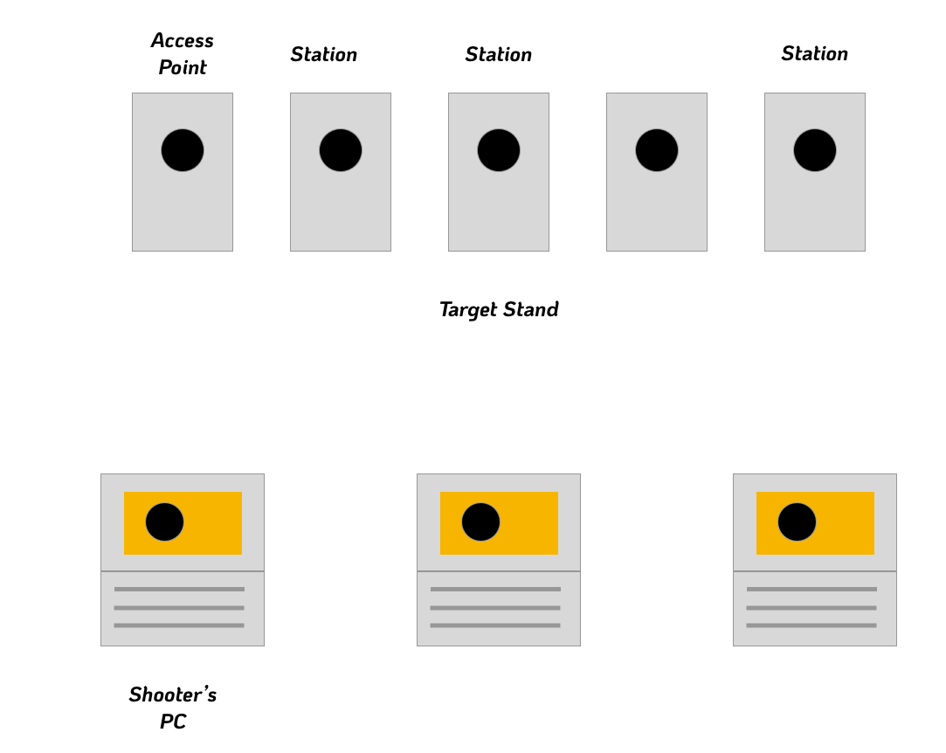
Figure 2: Simple Range Setup
Access Point Setup
The router should be setup for the convenience of the shooter and their PC. The following settings are suggested.
Setting | Value | Description
SSID | “” | Sets target into access point mode to manage the WiFi Network
Password | None (open wifi) | No secure data, easy to access for members
IP Address | 192.168.10.9 | Unique IP address that will not likely conflict with other networks

Target Setup
Subsequent targets should be setup with the following values
Setting | Description
{“WIFI_SSID”:”FET-…”} | Set to the same SSID as the first target
{“WIFI_PWD”:””} | No password used.  Use {“WIFI_PWD”:”mypassword”} if a password is used in the router.
{“NAME_ID”:x} | Select a unique (different) name ID for each target  See Appendix
 | Optional
{“WIFI_IP”:”IP address”} | Set in a static IP, ex {“WIFI_IP”:”192.168.10.111”}

ACCESSING THE TARGET
Once the targets and router have been setup, the target can be accessed much like any other network device you have.
Using the PC Client
In the client configuration, set in the IP address in the TCP configuration as shown in Figure 3
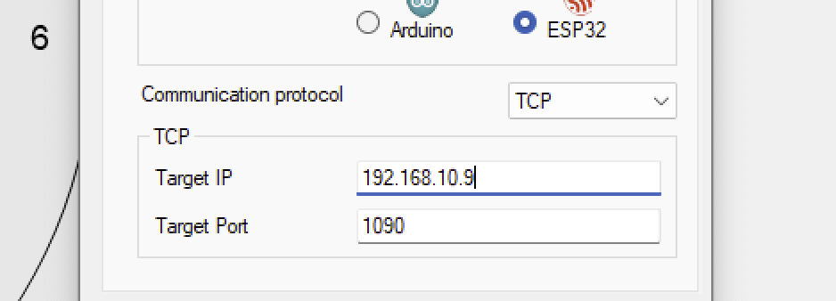
Figure 3: Setting the Target IP Address
When the target connects, it will connect to the IP address and begin the session.
The target will accept up to four simultaneous connections:
- Shooter
- Coach
- Parent
- Observer

Using a Web Browser
The target can be accessed as a web page using a web browser such as Safari or Chrome.
By IP address for example: 192.168.109.23
By target name, for example FET-TARGET.local

SECURITY
The design of FreeETarget assumed a fair amout of trust between the shooters and the shooting range. If this is not the case, then the following steps can be added
- Assign a WiFi password to the target range
- Lock out the target settings by assigning a lock code {“LOCK”:number}. This will prevent anyone from changing the settings unless an unlock code is provided {“UNLOCK”:number}

CAUTIONS
- When using the browser, only one connection will be accepted.
- The target has a WiFi range of fifty-meters in a clear line of sight with no obstructions
- The range manager should assign a WiFi password if they are concerned about security

APPENDIX 1
Target Names
NAME ID | Target Name
0 | TARGET (Default)
 | Numbers
1 | 1
2 | 2
3 | 3
4 | 4
5 | 5
6 | 6
7 | 7
8 | 8
9 | 9
10 | 10
 | Seven Dwarves
11 | DOC
12 | DOPEY
13 | HAPPY
14 | GRUMPY
15 | BASHFUL
16 | SNEEZY
17 | SLEEPY
 | Reindeer
18 | RUDOLF
19 | DONNER
20 | BLITZEN
21 | DASHER
22 | PRANCER
23 | VIXEN
24 | COMET
25 | CUPID
26 | DUNDER
 | Norse Gods
27 | ODIN
28 | WODEN
29 | THOR
30 | BALDAR
 | Custom
31 | TEST
99 | {“NAME_TEXT”:”myName”}. -> FET-myName
100 | {“NAME_TEXT”:”myName”}. -> myName
101 | Serial number -> FET-SerialNumber

